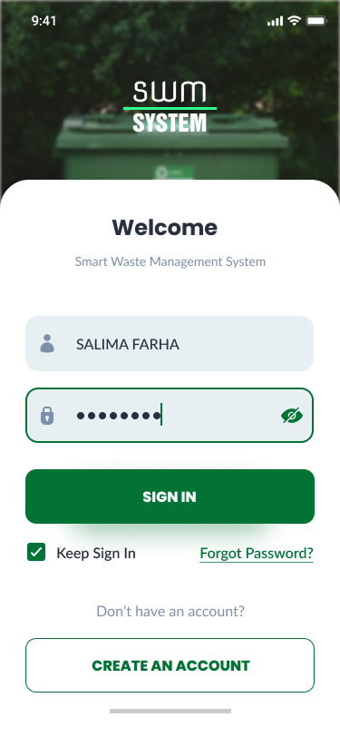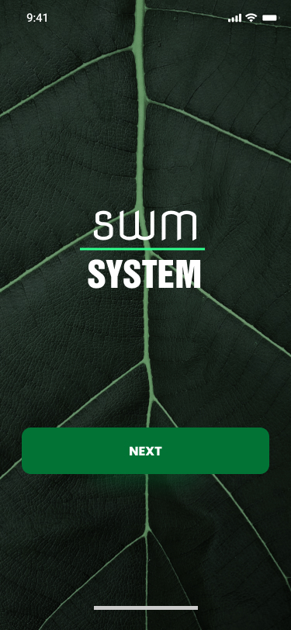**UI Design: Smart Waste Management System.**

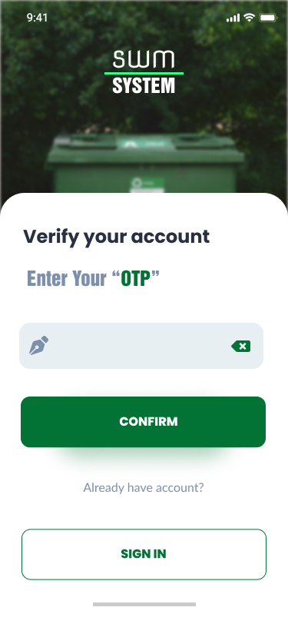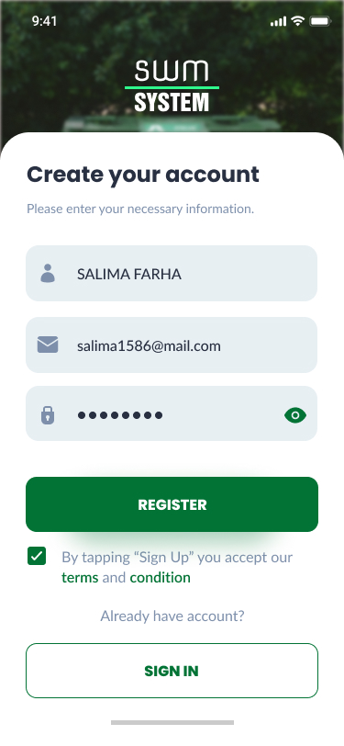

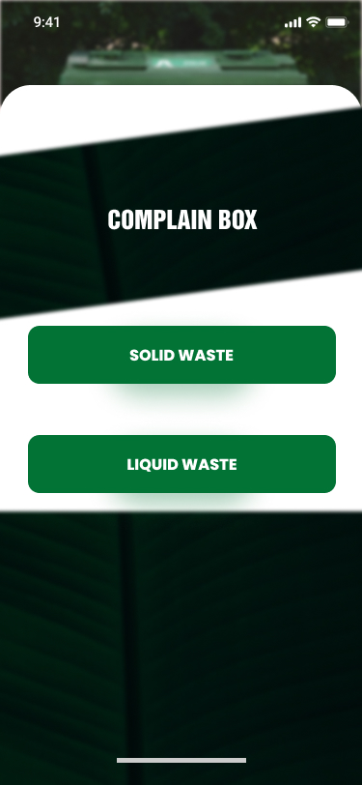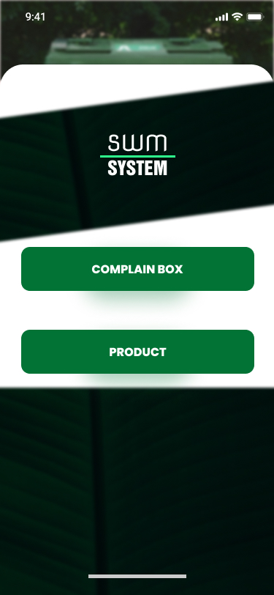

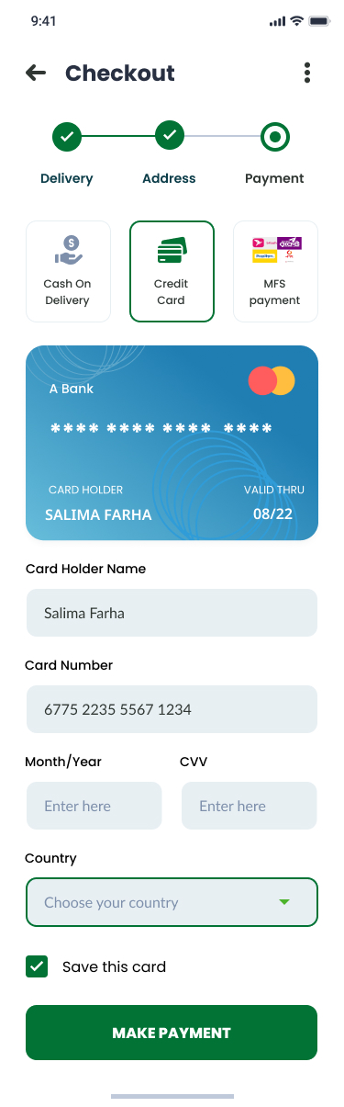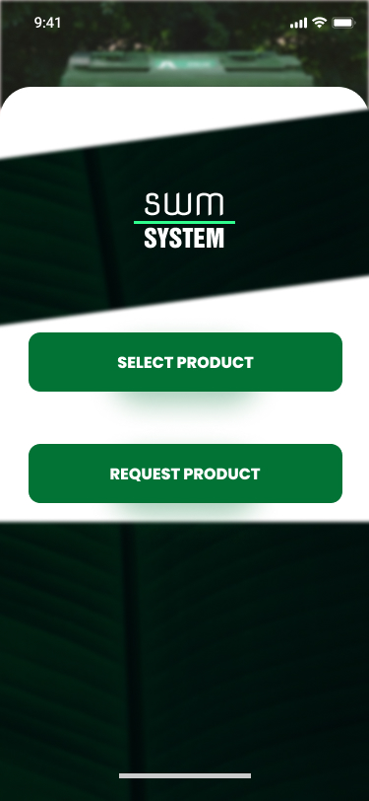

User Story Template

**Title:** Registration

**Priority: High**

**Estimate:**

1 Week

**As a** *User*

**User wants to** register in the waste management system.

**so that User can** create an account in the system

**Acceptance criteria**

**Given** User don’t have an account

**When** User enter the email address and password and a user name select the “Register”

**Then** his or her profile / account will be created after verifying.

Platform: Cross platform (Desktop,Mobile)

Language/framework: JavaScript/Nodejs

User Story Template

**Title:** Complaint Box

**Priority: High**

**Estimate:**

1 Week

**As a** *User*

**User wants to** interact with city corporation to have a waste management service.

**so that User can** explain my problem and get the desirable service.

**Acceptance criteria**

**Given** User have a valid information and address and I have accepted the condition and gone through the rules and regulation.

**When** User select the “Complaint box” option.

**Then** User will have the select option whether the waste is liquid or solid waste.

Platform: Cross platform (Desktop,Mobile)

Language/framework: JavaScript/Nodejs

User Story Template

**Title:** Product

**Priority: Medium**

**Estimate:**

1 Week

**As a** *User*

**User wants to** interact with the software to select or request some product.

**so that User can** buy or order any product

**Acceptance criteria**

**Given** User have a valid address, phone number and I have accepted the condition and gone through the rules and regulation.

**When** User select the product option.

**Then** User will have the select option whether he or she wants to add organic or inorganic product to it’s cart.

Platform: Cross platform (Desktop,Mobile)

Language/framework: JavaScript/Nodejs

User Story Template

**Title:** Payment

**Priority: High**

**Estimate:**

1 Week

**As a** *User*

**User wants to** make his or her payment to buy products.

**so that User can** have the buying service.

**Acceptance criteria**

**Given** User have a valid account and have a credit card / mobile banking account.

**When** User select Checkout and chooses a payment method (cash on delivery, card or mobile banking). If user choose card then user need to give his or her card information and if choose mobile banking then he or she need to use mobile number and pin to confirm the payment.

**Then** user will be able to make payments using my chosen method.

Platform: Cross platform (Desktop, Mobile)

Language/framework: JavaScript/Nodejs